SQL JOINS EXERCISE

QUESTION 1
Show every user who has a subscription. Match users to subscriptions. TAB L E S TO US E users · subscriptions EXP ECT ED COL UMNS user_id, user_name, subscription_id, start_date
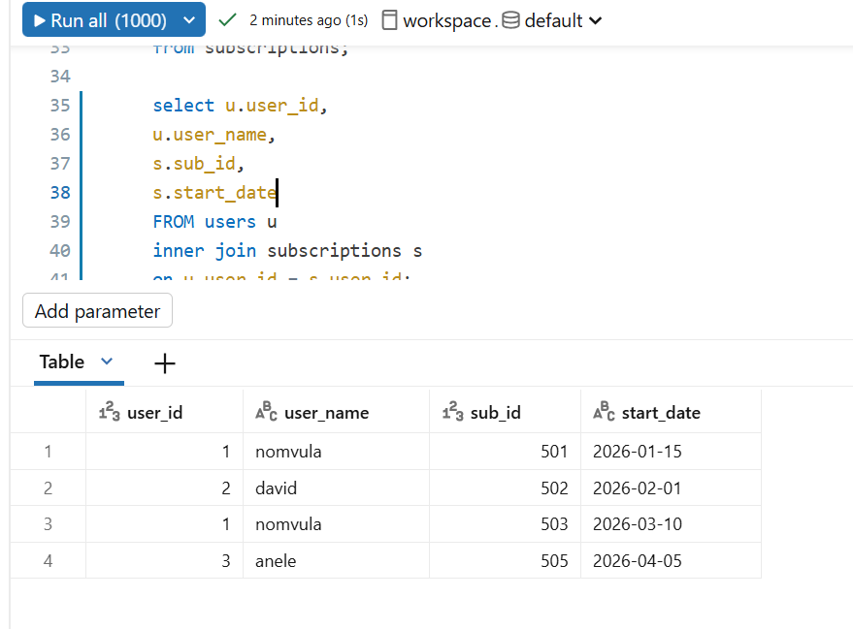
QUESTION 2
Show every subscription with its matching plan name and monthly price. TAB L E S TO US E subscriptions · plans EXP ECT ED COL UMNS subscription_id, user_id, plan_name, monthly_price
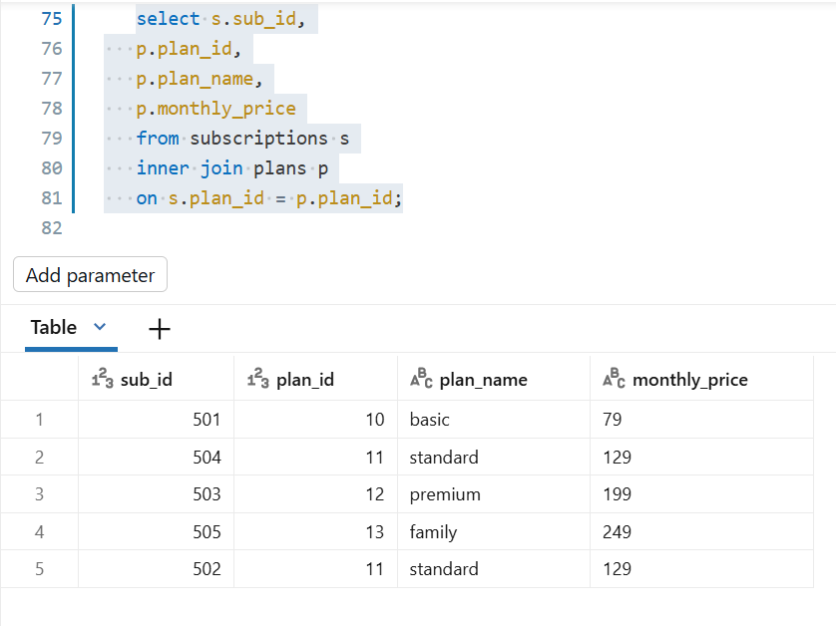
QUESTION 3
Show every viewing session that has a matching show. Include the show title and genre. TAB L E S TO US E viewing_sessions · shows EXP ECT ED COL UMNS session_id, user_id, show_title, genre, watch_minutes
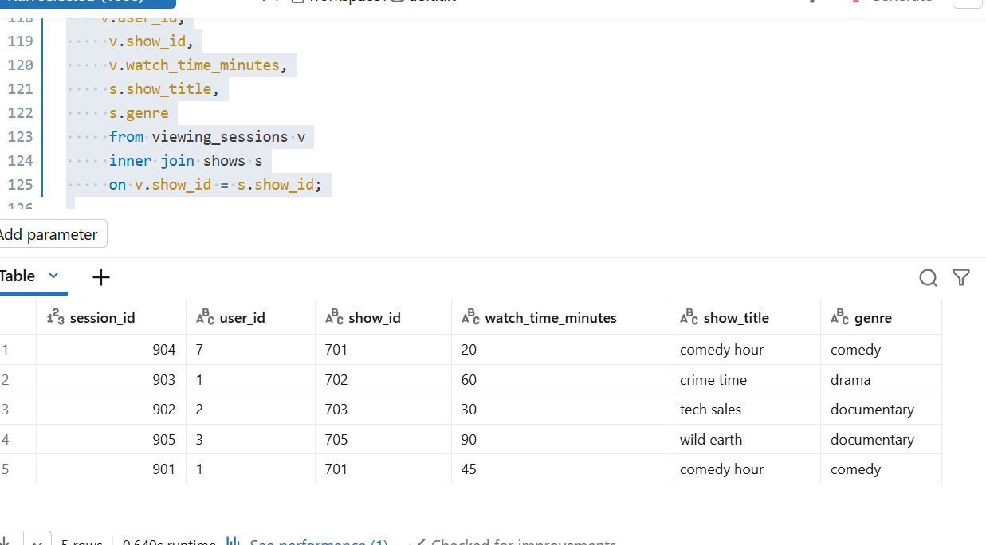

QUESTION 4
Show every viewing session with the user who watched it. Only show sessions with a matching user. TAB L E S TO US E users · viewing_sessions EXP ECT ED COL UMNS user_name, country, session_id, show_id, watch_minutes
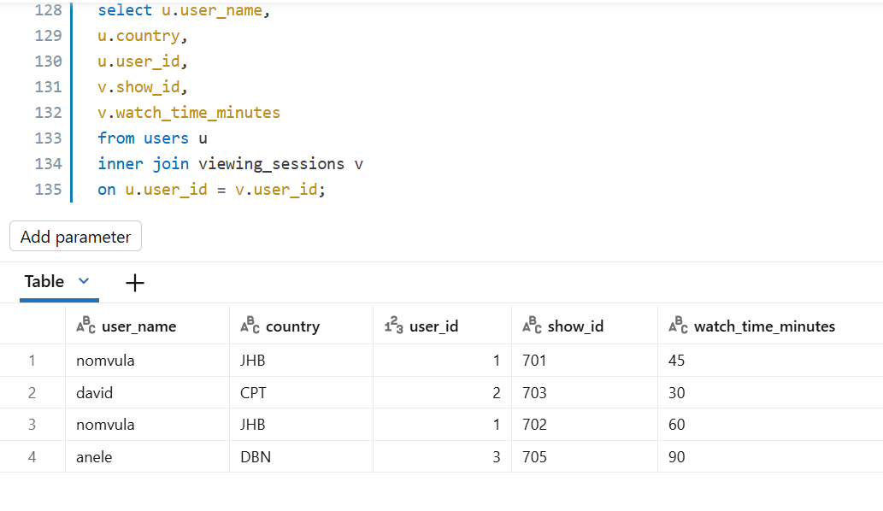
QUESTION 5
Show users along with their subscriptions, the plan name, and the price. Use only users who have both a subscription and a valid plan. TAB L E S TO US E users · subscriptions · plans EXP ECT ED COL UMNS user_name, country, plan_name, monthly_price, start_date
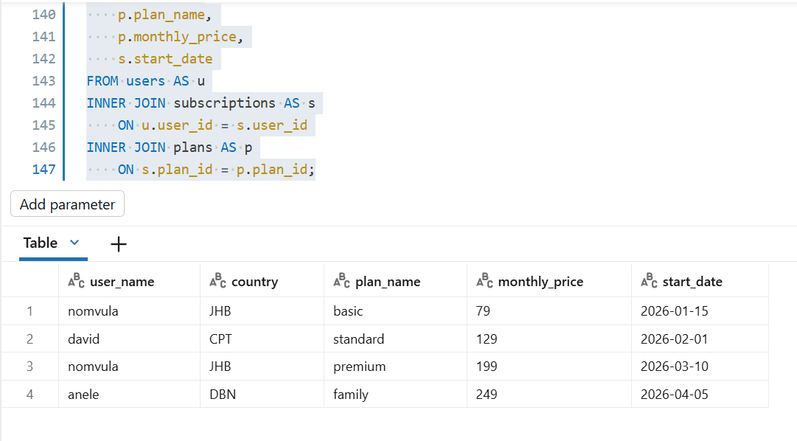

QUESTION 6
Show every user and any subscriptions they have. Users without subscriptions must still appear. TAB L E S TO US E users · subscriptions EXPECTED COLUMNS user_id, user_name, subscription_id, start_date
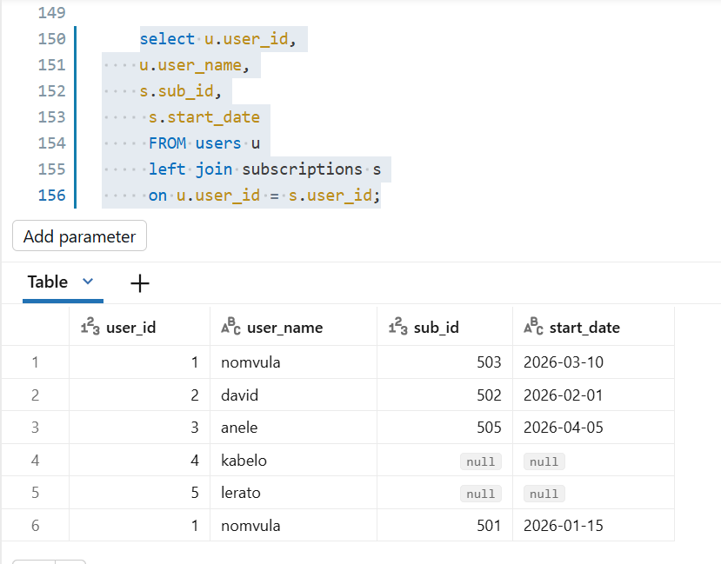
QUESTION 7
Show every plan and the subscriptions on it. Plans with no subscribers must still appear. TAB L E S TO US E plans · subscriptions EXP ECT ED COL UMNS plan_id, plan_name, subscription_id, user_id
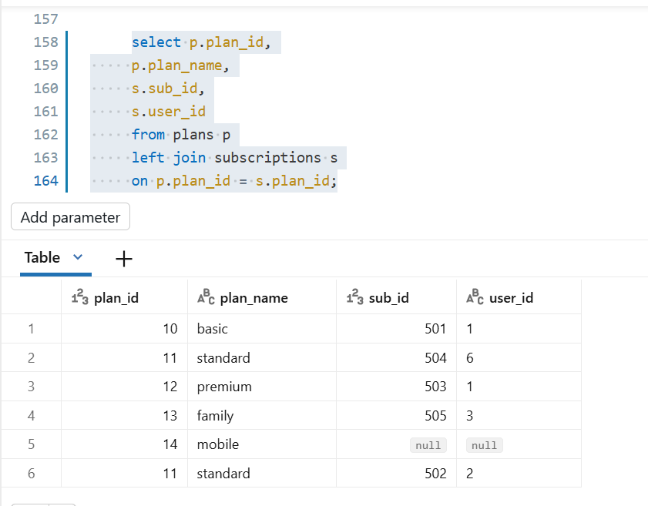
QUESTION 8
Show every show and any viewing sessions on it. Shows that were never watched must still appear. TAB L E S TO US E shows · viewing_sessions EXP ECT ED COL UMNS show_id, show_title, session_id, watch_minutes
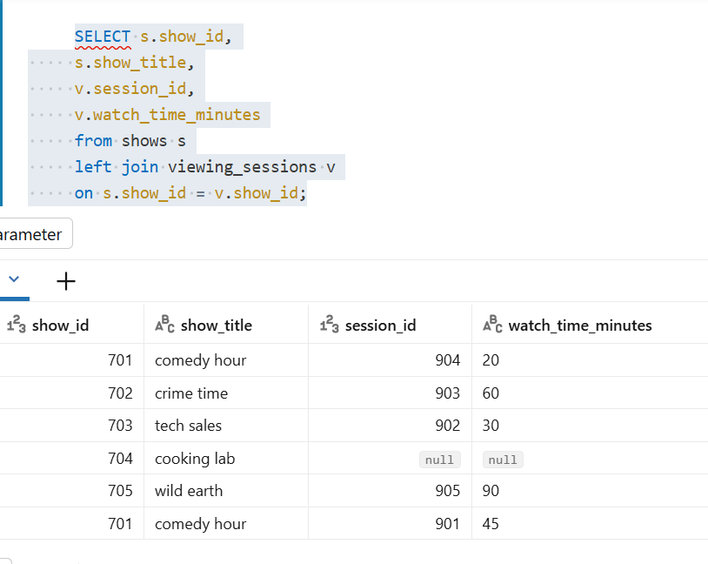
QUESTION 9
Show every viewing session and the user who watched it. Sessions referencing users that do not exist must still appear (with NULL user details). TAB L E S TO US E viewing_sessions · users EXP ECT ED COL UMNS session_id, show_id, watch_minutes, user_id, user_name
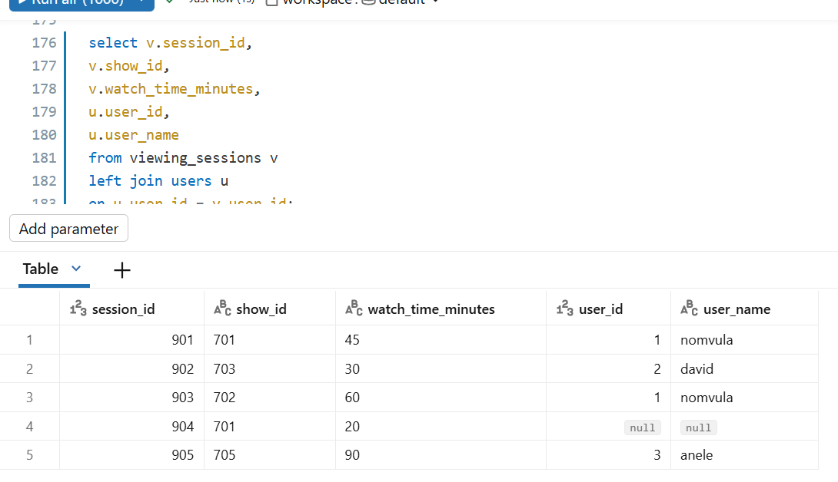
QUESTION 10
QU E S T I ON 1 0 Show every user, the plan they are on (if any), and the monthly price. Users without a subscription must still appear. TAB L E S TO US E users · subscriptions · plans EXP ECT ED COL UMNS user_name, country, plan_name, monthly_price
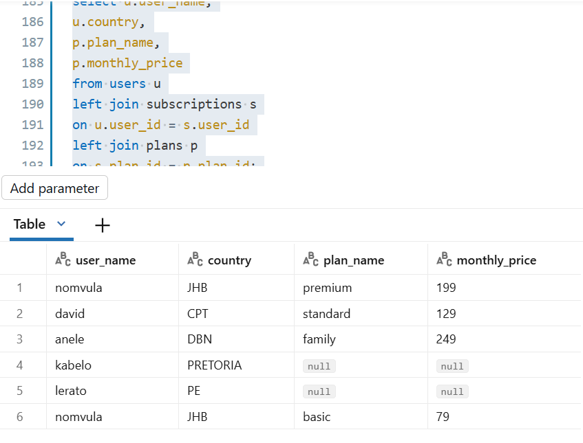
QUESTION 11
Show every user and every subscription, including users without subscriptions AND subscriptions referencing users that do not exist. TAB L E S TO US E users · subscriptions EXP ECT ED COL UMNS user_id, user_name, subscription_id, start_date
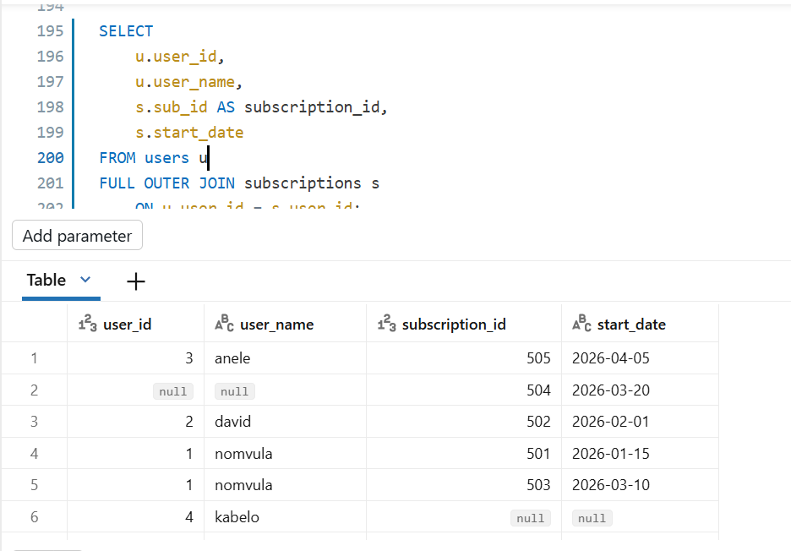
QUESTION 12
Show every plan and every subscription, including plans without subscribers AND any BrightLearn · SQL Joins Exercise Page 13 BrightLearn SQL JOINS EXERCI SE subscription referencing a plan that does not exist. TAB L E S TO US E plans · subscriptions EXP ECT ED COL UMNS plan_id, plan_name, subscription_id, user_id
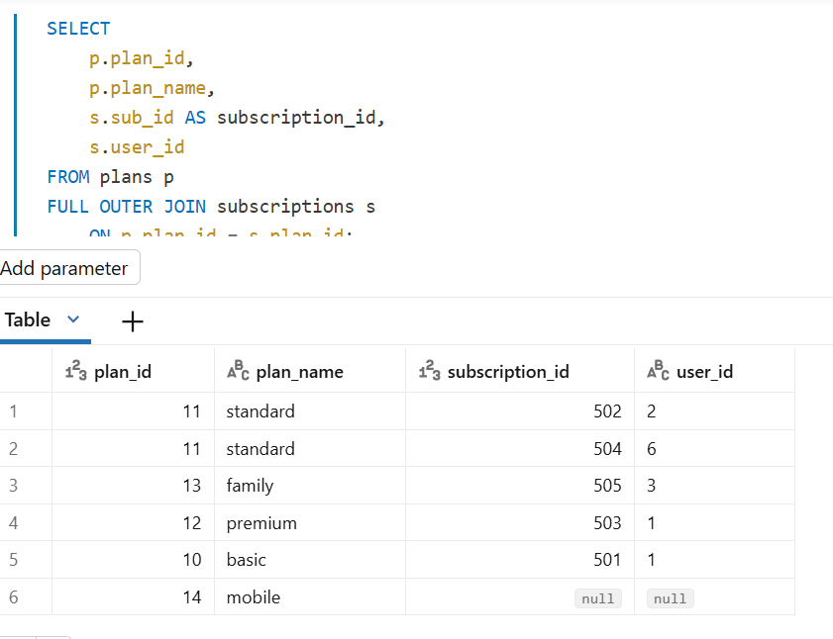
QUESTION 13
Show every show and every viewing session, including shows that were never watched AND sessions referencing shows that do not exist. TAB L E S TO US E shows · viewing_sessions EXP ECT ED COL UMNS show_id, show_title, session_id, watch_minutes
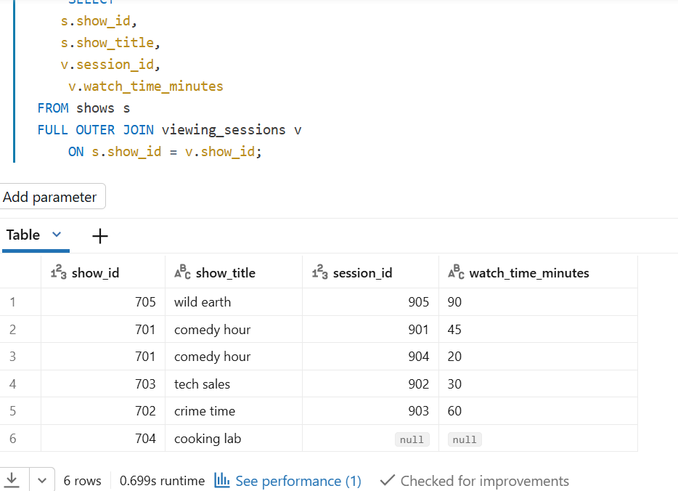

QUESTION 14
Show every user and every viewing session, including users with no sessions AND sessions referencing users who do not exist. TAB L E S TO US E users · viewing_sessions EXP ECT ED COL UMNS user_id, user_name, session_id, show_id, watch_minutes
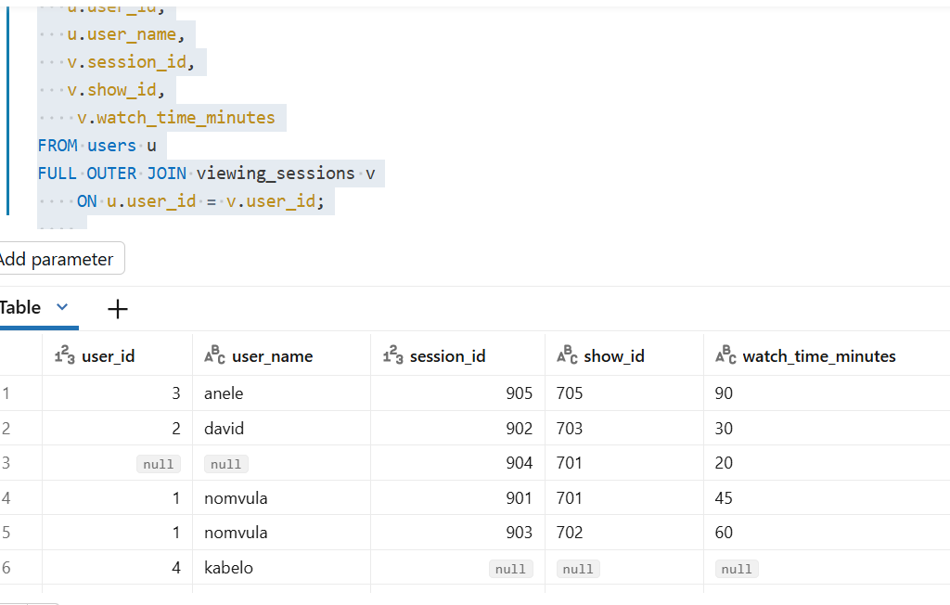
QUESTION 15
Show every user, every subscription, and every plan in one query — using FULL OUTER JOIN throughout. This is the hardest question — get all gaps visible at once. TAB L E S TO US E users · subscriptions · plans EXP ECT ED COL UMNS user_id, user_name, subscription_id, plan_id, plan_name
